Equipment System Documentation

Written and designed by Brad.

The following types of equipment are:

- Belt
- Glove
- Face
- Hair
- Helmet
- Pants
- Shirt
- Shoe
- Shoulder

Every piece of equipment has the following:

Unique ID
Every piece of equipment in the game will have a unique ID.

Type
The type of equipment (eg. Specifying if it's a belt, helmet, etc). See the ENUM::equipType in equipmentData.h

ID
The ID for the type of item. (eg. Belt 0, or shirt 0). Each type of equipment has their own sub ID system.

Name
This is the friendly name of the piece of equipment (the name that is displayed to users.)

All of this data is stored in
Dropbox\Grand Tale\Game\equipmentDatabase.s3db in the equipmentData table. This entire table is loaded at runtime into memory (into an std::map of equipmentData structures) on the server using equipmentDataManager::getAllEquipmentData();

Note! The table only contains general information for an item.
Dropbox\Grand Tale\Game\Assets\rawAssets\Data\character\<equipmentType>
Contains information for each piece of equipment such as sprite coordinates etc (AKA stuff that is used client side)

The Database table is only used SERVER Side.

The Data (.RAW) files for the equipment:
<SHORT> X Origin (usually the center of the sprite)
<SHORT> Y Origin (usually the center of the sprite)
<SHORT> Which Anchor point it's relative to
0 = Navel
1 = Head
2 = Left Hand
3 = Right Hand
4 = Left Foot
5 = Right Foot
<SHORT> Relative X to anchor point on body
<SHORT> Relative Y to anchor point on body
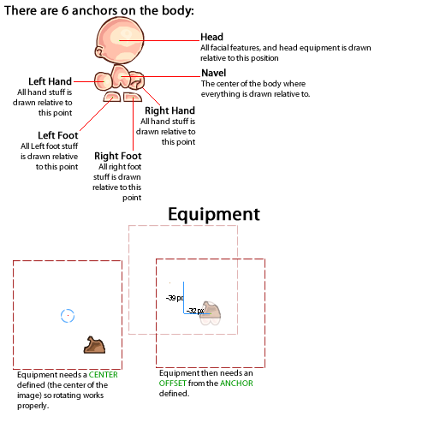

Belt:
Client side data is in:
rawAssets\Data\character\belt
It uses one data file (<ID>.raw). Containing the data.

